Flowboard – How to Use
A calm Trello-style task board with live teamwork and an AI Standup that writes your daily update.

What it does
- Boards with lists and cards you drag and drop (mouse or long-press on touch).
- Card details: description (Markdown), due date, labels, people, checklist, comments, links and a Blocked flag.
- Search and filters (label, member, due date, blocked).
- Activity log of every change in plain sentences.
- Live sync: changes appear instantly in every open window, with green "online" dots.
- AI Standup Mode: Done / In progress / Blocked / Overdue / By person, with a 0–100 focus score per person. Copy as Slack message or export as Markdown.
- Light and dark mode; works on phones.

How to open it on Windows
1. Open the flowboard folder on your Desktop.
2. Double-click start.bat. A black window opens.
3. Your browser opens http://localhost:3000 (if 3000 is busy it uses the next free port – check the black window).
4. Keep the black window open. Press Ctrl+C or close it to stop.

Demo logins
Name | Email | Password | Role
Maya Chen | maya@example.com | flowboard123 | Owner
Sam Rivera | sam@example.com | flowboard123 | Member
Priya Patel | priya@example.com | flowboard123 | Member

Or press Use demo account on the sign-in page, or create your own account. Demo boards: "Website relaunch" and "Q4 planning".

Step by step

Work with cards
1. Open the "Website relaunch" board.
2. Add a card with the composer at the bottom of a list (Enter to add, Esc to close).
3. Drag a card to another list. On a touch screen, press and hold for a moment first.
4. Click a card to open its details – add a due date, checklist, labels or a comment.
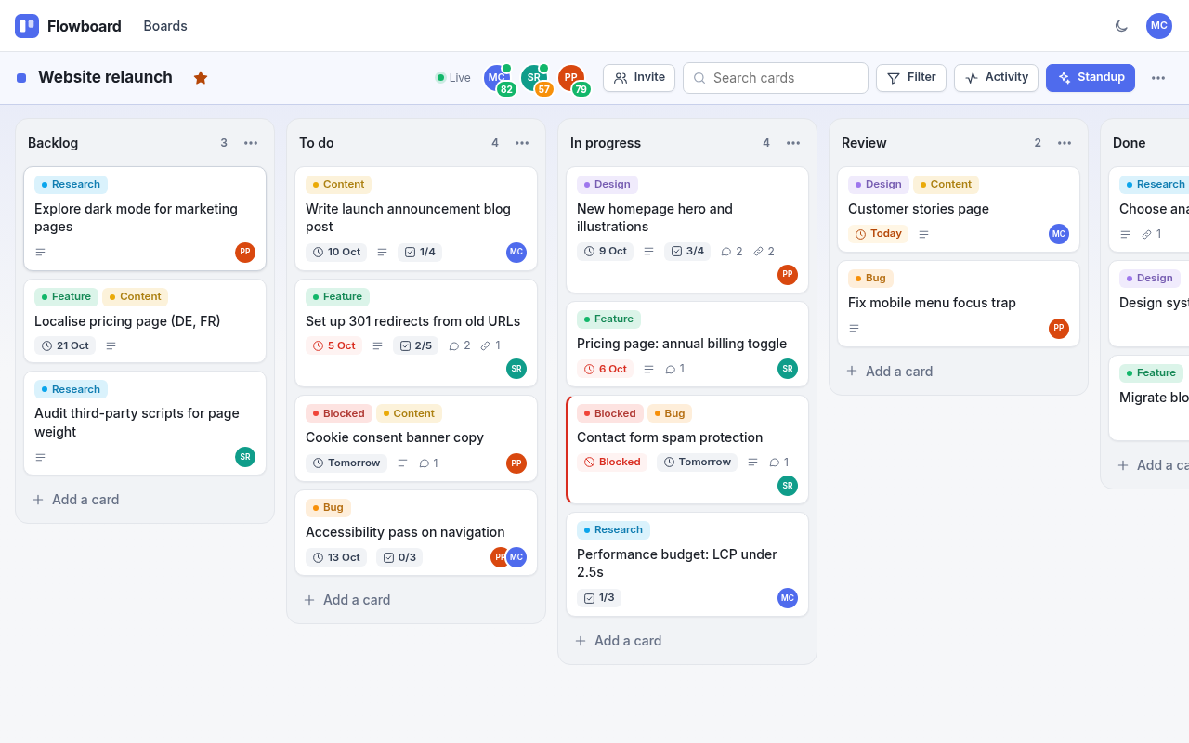
A Flowboard board
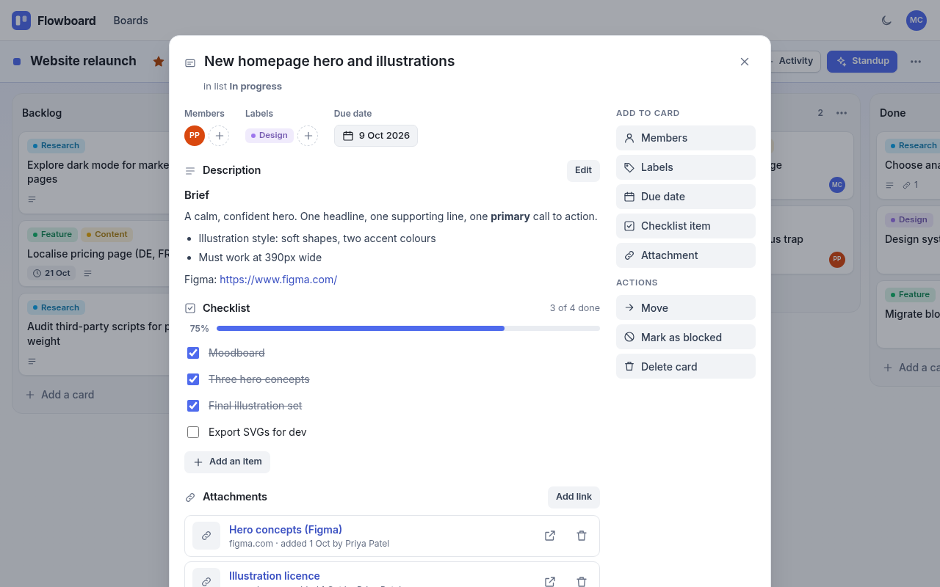
Card details

See live teamwork
1. Open Flowboard in a second browser (or a private window).
2. Sign in as Maya in one and Sam in the other and open the same board.
3. Move a card in one window – it moves in the other instantly.

Get your daily standup
1. On any board click Standup.
2. Choose 24 h, 48 h or 7 days.
3. Click Copy as Slack message or Export as Markdown.
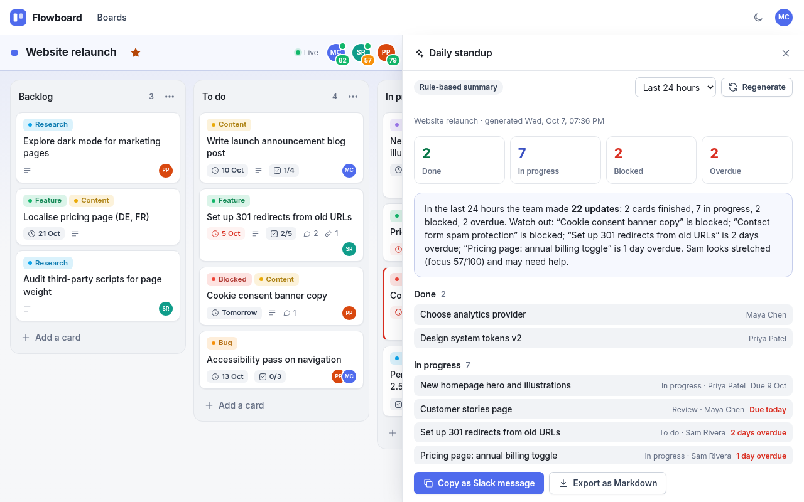
The AI Standup panel

Optional: turn on the AI write-up
Without a key the standup is rule-based – free, instant and always works. To get an AI-written version:
1. In the flowboard folder copy .env.example and rename the copy to .env.
2. Open .env in Notepad and fill in: AI_API_KEY= your key, AI_BASE_URL= (for example https://api.openai.com/v1) and AI_MODEL= (for example gpt-4o-mini).
3. Save, close the black window and run start.bat again.
It works with any OpenAI-compatible service (OpenAI, Azure, OpenRouter, Groq, or local Ollama/LM Studio). Only card titles, list/label/member names, due dates and counts are sent – never descriptions, comments or emails. If the AI fails, Flowboard falls back to the rule-based summary.

Your data and the database
Everything is saved in data\flowboard.db (SQLite), created on first run.

Start fresh (reset)
1. Close the black window.
2. Delete the data folder.
3. Run start.bat again – the demo boards come back.
To look inside, use the free DB Browser for SQLite (https://sqlitebrowser.org) with the app stopped.

Troubleshooting
Problem | What to do
The black window says "Node.js ... was not found" | Install Node.js 24 LTS from https://nodejs.org, restart the computer, then double-click start.bat again.
Port 3000 is busy / another app is open | Close the other black window (or the other app) and try again. The app tries the next free port automatically – read the address printed in the black window and type it into your browser.
The browser did not open | Open Chrome or Edge yourself and go to http://localhost:3000 (or the address shown in the black window).
The page will not load | Make sure the black window is still open. Closing it stops the app.
Windows SmartScreen / firewall warning | Click "More info → Run anyway" for start.bat. If asked about the firewall, choose Private networks.

Honest limitations
- Attachments are links only – no file uploads.
- No emails: invites only work for people who already have an account, and there is no password reset.
- No undo or archive – deletes are permanent after you confirm.
- If two people edit the same description at once, the last save wins.
- The focus score is a rough guide, not a performance measure.
- It runs on your own computer only (127.0.0.1) unless you host it.

